Version 2:

**Requête des KPI**

KPI 1 : Le chiffre d’affaire

Le chiffre d’affaire total / variable temporelle

SELECT sum(priceEach * quantityOrdered) as Chiffre_affaire FROM orderdetails

JOIN orders ON orders.ordernumber= orderdetails.ordernumber;

Le chiffre d’affaire / produits → Ajouter variable temporelle

SELECT date_format(orderdate, "%M %Y") as commande_mois_annee, productline, sum(quantityOrdered) as totalquantity, sum(orderdetails.priceeach * quantityOrdered) as CA

FROM orderdetails

JOIN products ON products.productCode = orderdetails.productCode

JOIN orders ON orders.ordernumber= orderdetails.ordernumber

GROUP BY commande_mois_annee, productline;

KPI 2 : Les produits

Les plus vendus   
SELECT productCode, productName, productLine, quantityInStock, (AVG(priceEach) - buyPrice) as marge

FROM Orderdetails

Join products USING(productcode)

Group by productCode

ORDER BY marge DESC;  
Les moins vendus

WITH flop_prod as (

SELECT productline, productname, sum(priceeach * quantityordered) as ca_total,

RANK() over (partition by productline order by sum(priceeach * quantityordered) ) as rank_prod

FROM products

LEFT JOIN orderdetails USING(productcode)

GROUP BY productline, productname

ORDER BY productline , CA_total asc)

SELECT * from flop_prod

WHERE rank_prod <= 5;

KPI 3 : Les clients

WITH ca_evolution_client as (

SELECT customerName ,sum(priceeach * quantityordered) as ca_total,

sum(CASE WHEN year(orderdate) = year(now()) THEN priceeach * quantityordered

ELSE 0

END ) as ca_N,

sum(CASE

WHEN year(orderdate) = year(now()) - 1 THEN priceeach * quantityordered

ELSE 0

END ) as ca_N_1,

sum(CASE

WHEN year(orderdate) = year(now()) - 2 THEN priceeach * quantityordered

ELSE 0

END ) as ca_N_2

FROM customers

LEFT JOIN orders USING(customernumber)

LEFT JOIN orderdetails USING(ordernumber)

WHERE year(orderdate) >= year(now()) - 2

GROUP BY customerName

ORDER BY customerName asc ),

ca_total_tous as (

SELECT sum(quantityordered * priceeach) as ca_tous_temps

FROM orderdetails)

SELECT * , (CA_N - CA_N_1) * 100 / CA_N_1 as RATIO_24_23, round(CA_total * 100/ ca_tous_temps,1) as percent_ca_tous_temp,

CASE

WHEN CA_N = 0 THEN "relancer le client"

WHEN CA_N = 0 and CA_N_1 = 0 THEN "client perdu"

ELSE "autre"

END as classe_client

FROM ca_evolution_client

CROSS JOIN ca_total_tous

ORDER BY percent_ca_tous_temp desc ;

Autre methode :

SELECT customerName,

SUM(quantityordered * priceeach) as CA,

SUM(quantityordered * priceeach) * 100

/

(SELECT SUM(od.quantityordered * od.priceeach)

FROM orders

LEFT JOIN orderdetails as od USING(orderNumber)

WHERE `status` = "shipped" ) as total_ca

FROM customers

LEFT JOIN orders USING(customerNumber)

LEFT JOIN orderdetails USING(orderNumber)

WHERE `status` = "shipped"

GROUP BY customerName

ORDER BY CA desc;

Premiere Version

Rébecca

**Requête des KPI**

KPI 1 : CA total par année

-- Je fais le CA Total pour année 2022

SELECT sum(priceEach * quantityOrdered) as Chiffre_affaire FROM orderdetails

JOIN orders ON orders.ordernumber= orderdetails.ordernumber

WHERE orderdate LIKE "%2022%";

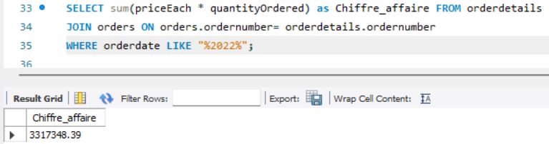

-- Je fais le CA Total pour année 2023

SELECT sum(priceEach * quantityOrdered) as Chiffre_affaire FROM orderdetails

JOIN orders ON orders.ordernumber= orderdetails.ordernumber

WHERE orderdate LIKE "%2023%";

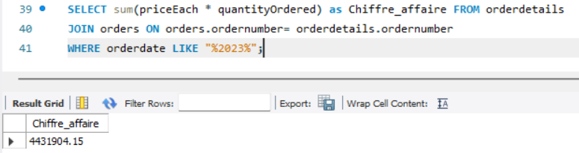

-- Je fais le CA Total pour année 2024 ***** ONLY Q1 ********

SELECT sum(priceEach * quantityOrdered) as Chiffre_affaire FROM orderdetails

JOIN orders ON orders.ordernumber= orderdetails.ordernumber

WHERE orderdate LIKE "%2024%";

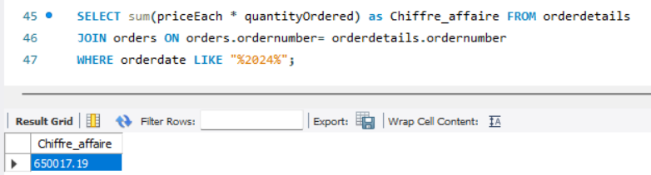

KPI 2 CA total par manager (RH)???

KPI 3 : Nombre de produits vendus par mois, par catégorie et par CA :

SELECT date_format(orderdate, "%M %Y") as commande_mois_annee, productline, sum(quantityOrdered) as totalquantity, sum(orderdetails.priceeach * quantityOrdered) as CA

FROM orderdetails

JOIN products ON products.productCode = orderdetails.productCode

JOIN orders ON orders.ordernumber= orderdetails.ordernumber

GROUP BY commande_mois_annee, productline;

Pour l’année 2024 uniquement :

SELECT date_format(orderdate, "%M %Y") as commande_mois_annee, productline, sum(quantityOrdered) as totalquantity, sum(orderdetails.priceeach * quantityOrdered) as CA

FROM orderdetails

JOIN products ON products.productCode = orderdetails.productCode

JOIN orders ON orders.ordernumber= orderdetails.ordernumber

WHERE orderdate LIKE "%2024%"

GROUP BY commande_mois_annee, productline

ORDER BY commande_mois_annee, CA DESC;

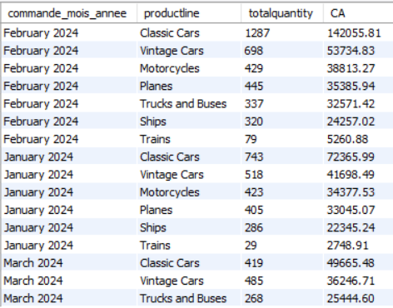

Les catégories qui se vendent le plus sur l’année 2024 sont les “classic cars” et les “Vintage cars”.

KPI 2bis : Taux de variation N-1

utiliser wonder function

KPI 3: i want to see if we have customer that didnt do any order

SELECT customerName, country, orderdate FROM customers

LEFT JOIN orders ON orders.customerNumber = customers.customerNumber

WHERE orderdate is NULL

ORDER BY country;

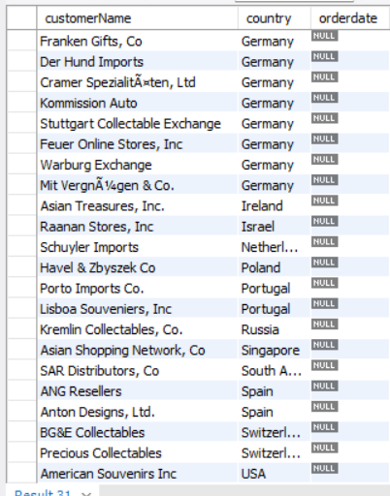

KPI 4 : Les 10 produits les moins commandés, leur stock et leur MSRP

SELECT productcode, productName, productLine, quantityInStock, AVG(priceeach), MSRP, sum(quantityOrdered) as quantitevendue

FROM orderdetails

JOIN products USING(productcode)

GROUP BY productcode

ORDER BY quantitevendue asc

LIMIT 10;

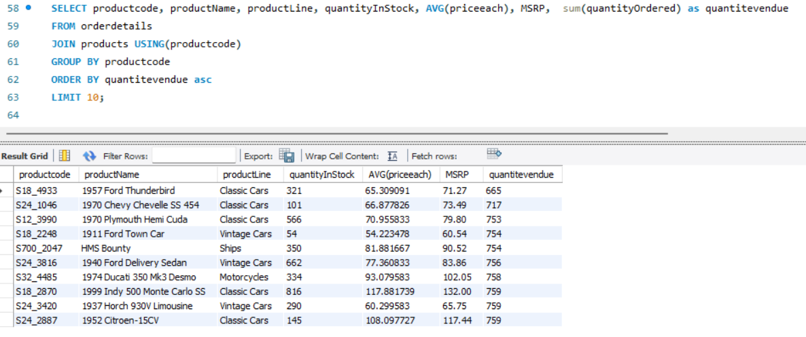

On est sous le MSRP pour tous les produits.

KPI 5 : Le produit qui fait le plus de ventes

SELECT productCode, productName, productLine, quantityInStock, (AVG(priceEach) - buyPrice) as marge

FROM Orderdetails

Join products USING(productcode)

Group by productCode

ORDER BY marge DESC;

